

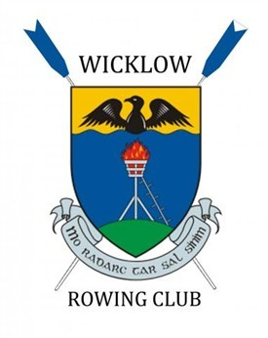

**Swift Irish Beach Sprints Championships**

**Time schedule**

**Link**

[https://docs.google.com/spreadsheets/d/1Y6vZJZhAMK2YLcCxh6gHaXfoUJ-mCdZwiaQB0838Nus/edit?usp=sharing](https://eur01.safelinks.protection.outlook.com/?url=https%3A%2F%2Fdocs.google.com%2Fspreadsheets%2Fd%2F1Y6vZJZhAMK2YLcCxh6gHaXfoUJ-mCdZwiaQB0838Nus%2Fedit%3Fusp%3Dsharing&data=05%7C02%7Crobert.dunne.rde%40servier.com%7Cc0206060bd8d4ff717c108dcb6d289f8%7Ccc0a4ff694544e4b881b85f448dee2e3%7C0%7C0%7C638586262582619013%7CUnknown%7CTWFpbGZsb3d8eyJWIjoiMC4wLjAwMDAiLCJQIjoiV2luMzIiLCJBTiI6Ik1haWwiLCJXVCI6Mn0%3D%7C0%7C%7C%7C&sdata=S1caXSIx%2BEbtXv3tjhN09rbTlEXnEz7G774c4JTAomo%3D&reserved=0)

**Please inform the regatta secretary of any scratches as it will affect the time schedule**