

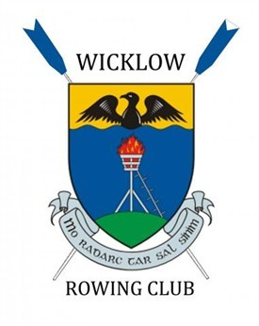

**Beach Sprints**

**Training Day**

**A training Day has been organised for Sunday August 11th after the Beach sprints championship . It is open to all qualifying athletes there may also be some places for non- qualifiers.**

**Please see schedule of events below :**

* **9.30am Meet at Wicklow RC clubhouse A67PF20 for briefing**
* **10.00 Arrive at CROSSFIT Gym South Quay Wicklow 3 min walk from the clubhouse for PLYO session with Luke Smyth**
* **13.00 Break for lunch**
* **14.00 leave for on the water session at Brittas Bay**
* **17.00 De-rig boats and Finish**