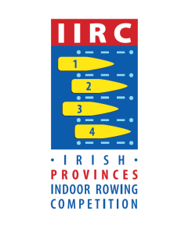
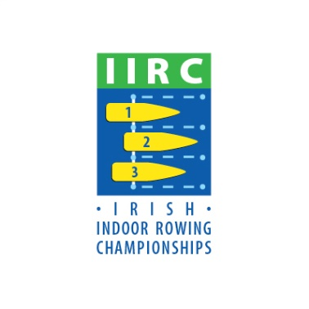

Results Link:

http://www.iirc.ie/results/

Choose your Event on the landing page.

Please note results are only posted when ALL races containing a category are run and verified.

