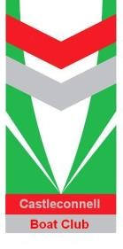
Castleconnell Sprints Regatta
5 lane 500 metre straight course
Saturday 20th May, 2023

Dear Club Secretary/Captain,
I am delighted to invite you, on behalf of Castleconnell Boat Club, to enter Castleconnell Sprint Regatta on Saturday May 20th 2023. Preparations for the regatta are coming to the final stages following on from a successful regatta last year. There has been significant interest from a number of clubs we hope that we will see you in May for what is set to be a great day’s racing.
Please see attached our regatta prospectus which details the events available at this year’s regatta. Please note that entries will close on Wednesday 10th of May at 7:00pm and that all entries must be made via the Rowing Ireland electronic entry system. The regatta event page can be found at https://www.rowingireland.ie/regatta-hors/events/.
Please do not hesitate to contact me if you have any queries over the coming weeks.
We look forward to welcoming you and your club to our regatta for what we hope will be a very enjoyable and competitive event.
Yours in Rowing,
Eoghan Meskell.

Eoghan Meskell
Regatta secretary | Castleconnell Regatta
Phone: 083 062 9809
Email: eoghanmeskell@hotmail.com
--

