Loughros Point Rowing Club
Endurance Regatta
Narin Beach Portnoo Sunday 1st June 2024

Events Offered
The following events will be offered at the at our endurance regatta

Event Event Code
Men’s Single CM1X
Men’s Double CM2X
Men's Coxed Quad CM4X+
Women’s Single CW1X
Women's Double CW2X
Women’s Coxed Quad CW4X+
Senior Mixed Quad CMix4X+
Mixed Double CMix2X
U18 Men’s Coxed Quad CJ18M4X+
U18 Women’s Coxed Quad CJ18W4X+
U18 Mens Double CJ18M2X
U18 Womens Double CJ18W2X
U18 Mens Single CJ18M1X
U18 Womens Single CJ18W1X
U18 Mixed Double CJ18Mix2X
U16 Womens Coxed Quad CJ16W4X+
U16 Mens Coxed Quad CJ16M4X+
U16 Womens Double CJ16W2X
U16 Mens Double CJ16M2X
U16 Mens Single CJ16M1X
U16 Womens Single CJ16W1X
U16 Mixed Double CJ16Mix2X

Regatta Entry Fees & Details Boat Type.
Single – €12.50
Double – €25.00
Quad – €62.50
Entries must be made via tracker. The closing date for entries is Wednesday 22nd May at 7pm
Payment is required for ALL crews entered into the competition.
Quote your Club Name as Reference on Payment

Payment Details:
Loughros Point Rowing Club. BK Credit Union, The Diamond Ardara.
BIC –BLDIIE21
IBAN –IE09BLDI99212810433897
Entries are invited from Rowing Ireland affiliated clubs with entries closing on 25/06/2024 at 7pm. Entries are accepted via Rowing Ireland's Tracker system from club secretaries or authorised persons only. Using the portal at the foot of the Rowing Ireland Website www.rowingireland.ie

Declarations & Scratches.

All entries will be assumed declared, unless the regatta secretary is informed of a crew scratch prior to the captain’s meeting. During the event all scratches must be submitted to regatta control in writing. Crews will be required to sign on and off the water. There will be no refunds for scratches.
Timetable
The race timetable will be made available after the close of entries.
SAFETY
All boats must be safety compliant and contain the correct equipment prior to launching; this includes crew life jackets present in the boat, bow rope and the cox wearing a life jacket. Hatch covers are secured firmly. It is the responsibility of each individual club and crew to ensure that all athletes are capable of handling weather conditions on the day of the event..
If a crew is visibly struggling in conditions a safety boat, can at their own discretion, help the boat or remove them from the race for their own safety. If conditions worsen throughout the day the regatta may be delayed or paused to allow for conditions to improve. Clubs will be informed of all decisions as they happen.
There will be very experienced Beach masters present to check all boats for :
- ● Correct amount and type of PFDs
- ● Properly tethered bow rope of at least 10 meters in length
- ● Correctly fitted and operational heel restraints
- ● Firmly closed hatches
- ● Boat damage that may be a safety risk Checks will also be carried out that the Boat numbers are correct and mounted in accordance with the rules and are clearly visible above the waterline. The beach masters will also ensure that the correct Sign in procedures are followed. If these conditions are not adhered to Boats will not be permitted to enter the water. There will be absolutely No exceptions and the Beach Marshall will oversee this. You have been pre advised. Safety is Paramount

Medical Assistance
- Trained medical personnel will be present during the event and will remain onsite for the duration of the event. There is a Defibrillator in a wall-mounted cabinet outside the public toilets at the carpark.

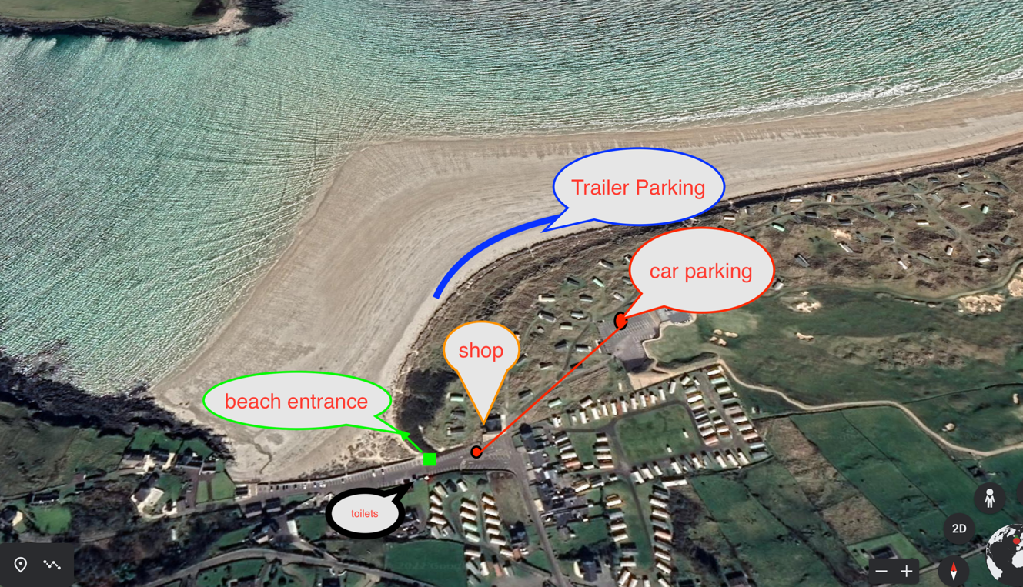
Event Map

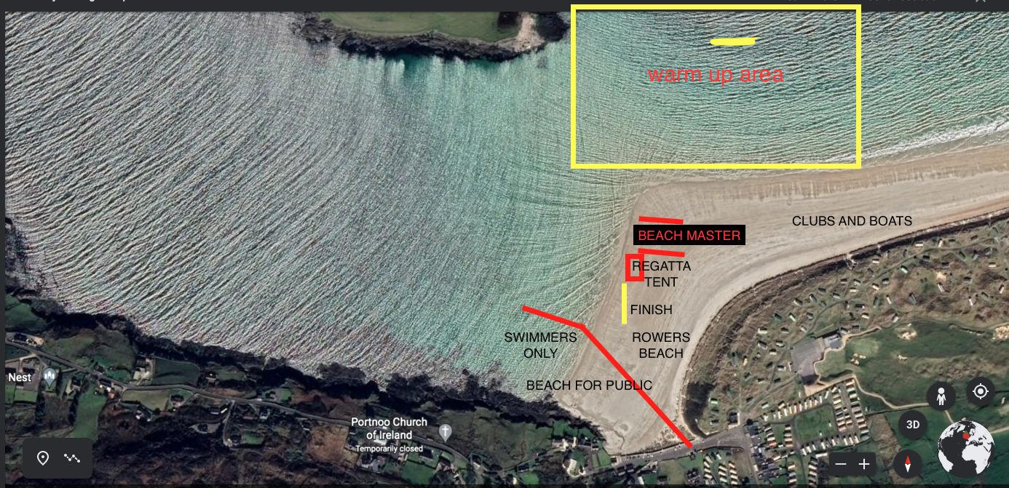

4K Course Map
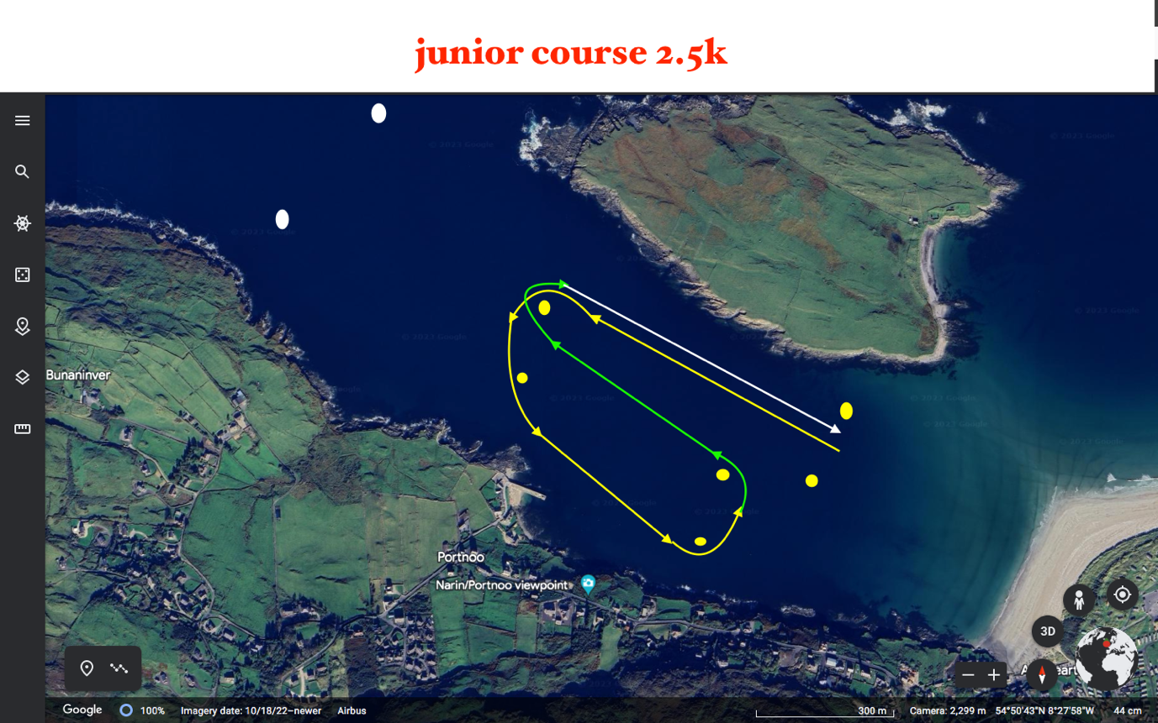
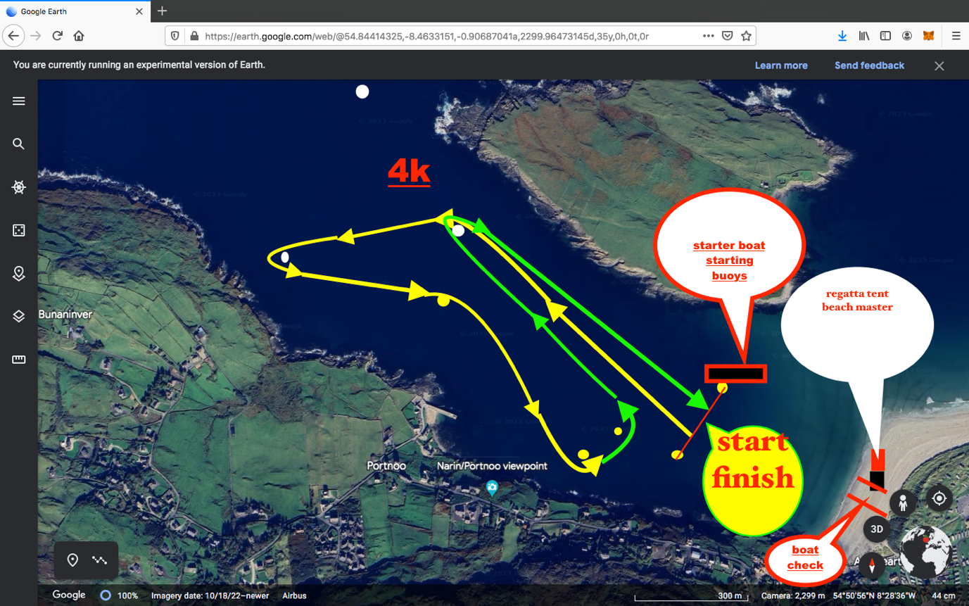

Facilities
Carparking - Please note carparking is free but space is limited to those on a first come first serve basis.
There are public toilets opposite the beach in the car park.
There is take away available beside Annoras pub on the way to the beach. There is also two coffee shops beside the beach.
Narin Portnoo Links restaurant is located 200m from the beach on the Golf Course.

