Loughros Point Rowing Club
Beach Sprints Qualifier
Narin Beach Portnoo Sunday 2nd June 2024

Categories Offered
Home International
CMX1 CWX1 CMixX2 CU23MixX2
CJMX1 CJWX1 CJMixX2
Winners of each category will qualify for the Homes International Beach Sprints in Bournemouth on the 28th September 2024
Coupe de la Jeunesse

CJMX1 CJWX1 CJMixX2

CJMX2 CJWX2
Winners of each category will qualify for the Coupe de la Jeunesse Beach Sprints on the 1st-3rd November in Spain

Pool Boats
Pool boats will be used for racing and will be provided by Kanghua.
Athletes are responsible for providing their own oars and boat handlers.

Entries
Entries must be made via tracker. The closing date for entries is Wednesday 22nd May at 7pm
The entry fees are as follows:
Single €20 Double €40
Fees are payable by bank transfer and are due on the 25th May 2024. Please make one payment per club and include a reference ‘Club name endurance’ or ‘Club name sprints’ or ‘Club name both’ if doing both events.
Payment Details:
Loughros Point Rowing Club. BK Credit Union, The Diamond Ardara.
BIC – BLDIIE21
IBAN – IE09BLDI99212810433897

Declarations and Scratches
All entries will be assumed declared, unless the regatta secretary is informed of a crew scratch prior to the captain’s meeting. During the event all scratches must be submitted to regatta control in writing. There will be no refunds for scratches.
Prizes
Pennants will be awarded to the winners of each category.
Timetable
The race timetable will be made available after the close of entries. Each crew entered will first race in a time trial. The full progression system will be published after close of entries.
It is anticipated that racing will begin around 12 noon due to the tide

Captain’s Meeting
There will be a captain’s meeting at 10:30am. Each crew must be represented at this meeting.
Medical Assistance
There will be medically trained personnel on site throughout the day.

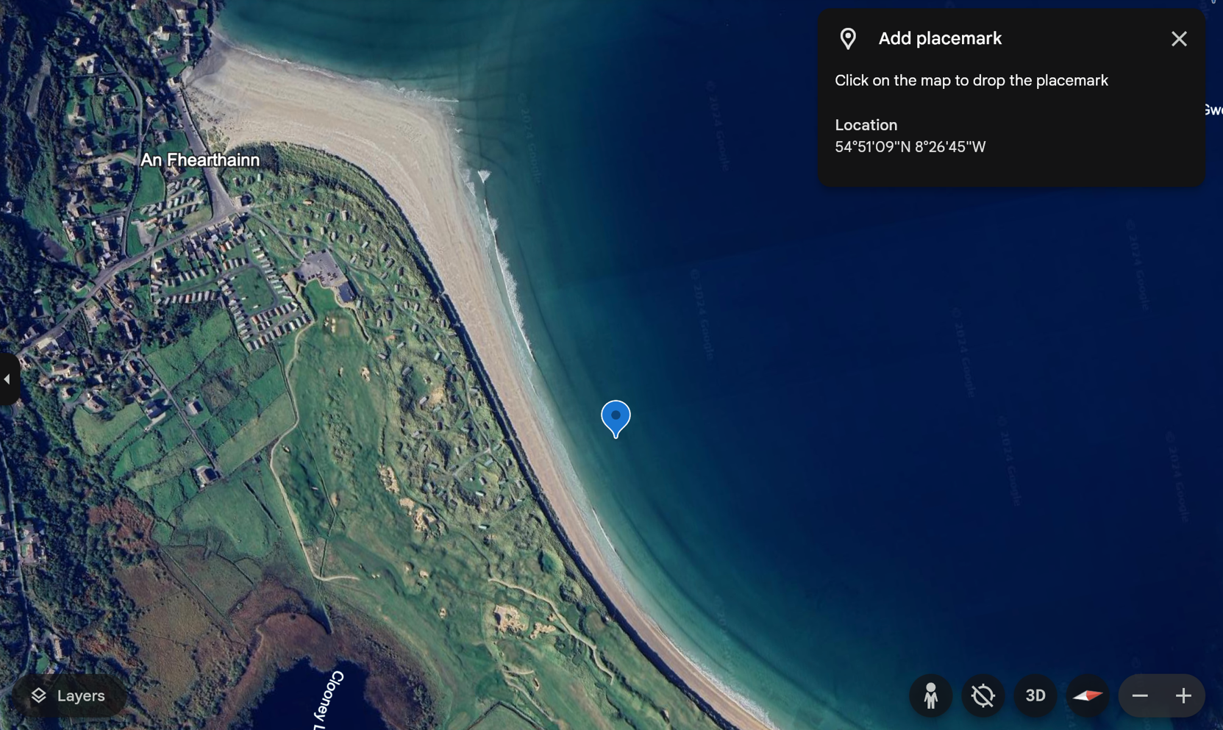
Course Map

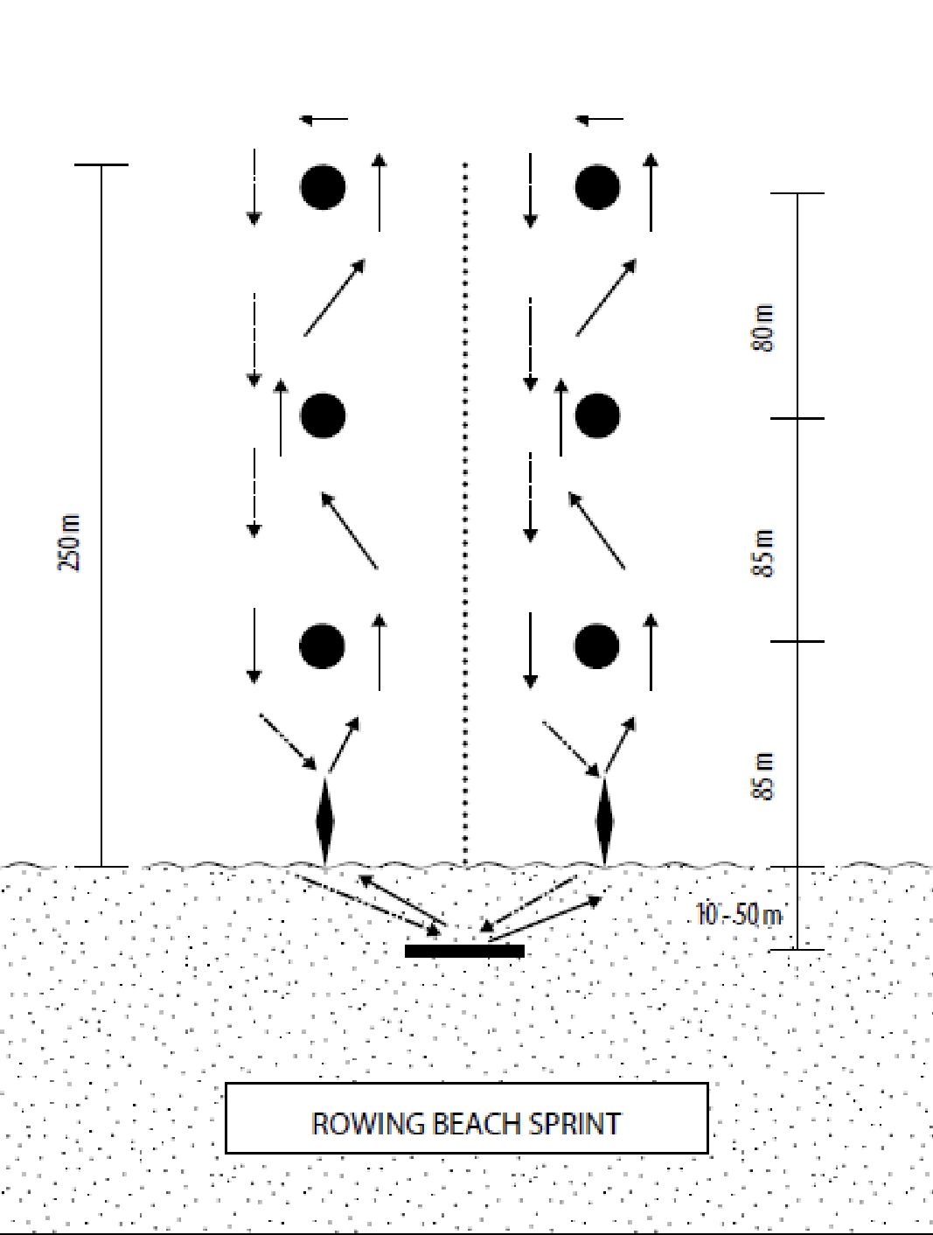

Race Procedures
The course features a beach start and beach finish. The starting sequence will be as follows:
3 minutes to race start: All crew members should be in the start zone and under the control of the starter. The Starter may penalise a crew which is late to the start and may start the race without reference to absentees.
1 minute to race start: When there is one minute to the start, the Starter shall say “One Minute, Get Ready”. After this the runners will position themselves behind the start line and the Starter shall instruct the other members of the crew and/or the boat handlers to “put the boats in the water.”
30 seconds to race start: When there are between 20 and 30 seconds to the start, the Starter shall alert the crews by saying “Get ready!”, after which alert the Starter may start the race at any time, having taken into account the wave conditions and any other factors.
20 seconds to race start: To give the start signal, the Starter shall first say “Attention!”; After a clear pause, The Starter shall then raise the red flag; After a clear and variable pause, the Starter will then start the race by dropping the red flag quickly to one side and simultaneously sounding a hooter in one long blast.
False Start
A crew commits a false start if the crew’s nominated runner crosses the start line before the start signal is given or if any crew member starts to board their boat before the start signal is given. The Judge at the Start shall be the sole judge of a false start.
The finishing sequence will be as follows:
The Finish Line of the race will be marked by a clear, straight line on the beach which the runner from each crew must cross. There shall be a flag placed at the water’s edge for each lane in line with the lane buoys and an equal distance from the finish line. Each runner shall pass on the outside of the flag when running from their boat to the finish line. A runner not passing on the correct side of the flag shall receive a penalty of 5 seconds. The finish of the race for each crew shall be the moment their crew member (the runner) crosses the finish line and hits the buzzer.

Race Procedures
It is important to note the following:
- One nominated crew member from each crew shall be a runner. (The runner at the start may be different from the runner at the finish but in both cases must be a member of the crew).
- The runner shall stand behind the start line which shall be clearly marked on the beach. The remaining crew members (except for solo (C1x)) shall be standing in the water holding their boats.
- No crew members shall start to board their boats before the start signal has been given.
- When the start signal is given the runners shall run to their boats to join the other crew members. The other crew members may start to board their boats as soon as the start signal is given
- Each crew is required to secure their own boat handlers.
- The boat handlers will hold the boat in place until the crew sits in and rows away.

False Start
A crew commits a false start if the crew’s nominated runner crosses the start line before the start signal is given or if any crew member starts to board their boat before the start signal is given. The Judge at the Start shall be the sole judge of a false start. Where a false start is committed, whether by a runner or other crew member, the Judge at the Start shall immediately raise a red flag and the Starter shall stop the race by waving a red flag and sounding repeated blasts on the hooter until all crews have stopped. The Judge at the Start shall inform the Starter which crew has caused a false start and the Starter shall award the crew a Yellow Card. A crew causing two false starts shall be excluded from the event by the Starter.

