Munster Branch Regatta
June 8th 2024
National Rowing Centre, Farran Wood, Co. Cork.

Regatta Safety Plan 2024
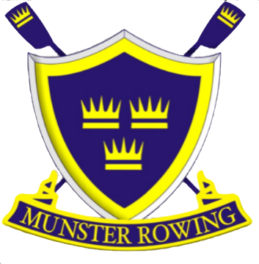

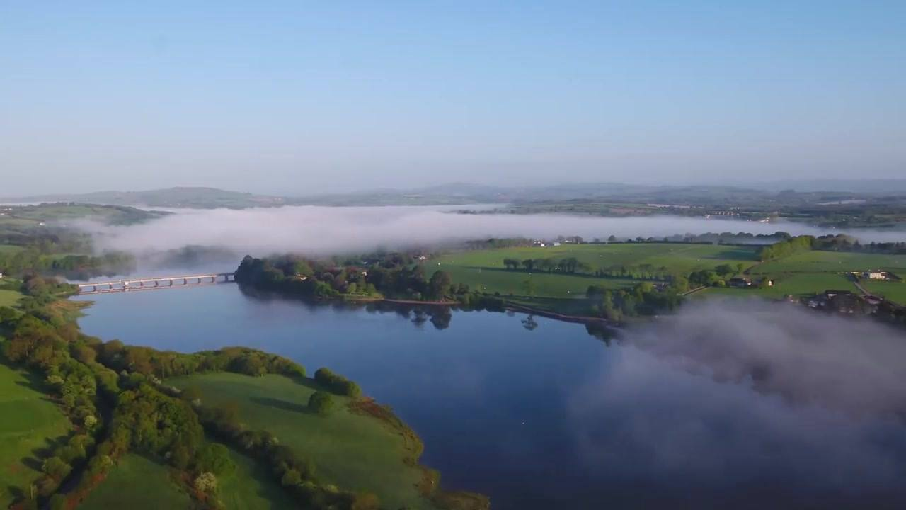

Contents
Introduction: 4
Safety Procedures & Preventive Measures 4
Equipment: 4
Coxes: 4
Swimming Ability: 4
Competitors’ Responsibility 4
Lake Hazards 5
Launching Plan Slipway 5
Traffic Plan 6
Racing 6
Know the rules: 6
If you see an accident: 6
Appropriate Foot ware 7
First Aid During the regatta 7
Key Telephone Numbers 7
Incidents – Collisions & Capsizes 7
Above the start/below the finish: 7
On the course: 7
Umpires and marshals: 7
Capsize: 8
Incidents – Extreme weather conditions & other threats 8
Pre-inspection 8
Instructions 8
Communications 9
Emergency Action Plan 9
Purpose 9
Responsibility 9
Actions in the event of a medical emergency 9
Emergency Radio Messages 10
Fire 10
Equipment failure 10
Capsize 10
Floating Hazard 11
Anti-social Behaviour 11
Terrorist Threat 11
Reporting of incidents 11
Emergency Services Access 11
Traffic Rules ‘Racing’ Normal Water Levels 12
Traffic Issues Near Finish Line 12
Slipway Traffic Pattern 13

Introduction:
Welcome to the second Munster Branch Regatta here at the NRC. We hope that you have an enjoyable, safe and successful regatta. Hopefully the weather gods will be kind to us and give us a good day of competitive racing and enjoyment.
We are requesting your help and co-operation, so that we can manage the any challenges that may emerge. If we can work together, we shall have a good s, safe and successful event.
This Safety Plan incorporates the key points of all the rowing clubs involved, our aim is that all competitors, officials and visitors will uphold all Good Practice that exist in Rowing throughout all the clubs participating this weekend.
A copy of the Safety Plan is lodged with Rowing Ireland on the tracker website and will be available to all.
Ambulance personal will be on site for each day of the regatta.
Safety boats crewed by trained personnel will be patrolling the course throughout the regatta. Umpires are equipped with loudhailers and basic safety equipment in rescue bags; throw-bags and emergency blankets, etc.
Safety boats, umpires and other regatta officials are provided with hand portable radios operating on the Umpires’ channel for communications.

Safety Procedures & Preventive Measures
Safety Instructions & Information for Competitors
Equipment: It is the responsibility of each crew to ensure that the equipment that they are using is safe and compliant with the requirements of Rowing Ireland’s rules.
Coxes presenting at the pre-launch inspection without proper life jackets on will not be allowed on the water. Coxes of front-loading boats should ensure that their life jackets allow for a quick escape from their boat.
All boats must have secure bow balls, heel restraints and watertight buoyancy chambers. Coxswains must wear a life jacket or buoyancy aid in the correct manner and be familiar with the method of operation. In “front-loader” boats coxswains must wear manually operated gas inflation life jackets or solid PDF type life jackets. Inspections will be conducted, and omissions may lead to disqualification.
Coxes: All coxes should be familiar with the method of operation of their life jacket.
Swimming Ability: Every competitor is expected to be in good health and able to swim. Although the lake is wide access from the bank is relatively good.

Competitors’ Responsibility
While we endeavour to provide a safe system at this event, each competitor and competing club also has a duty of care to themselves and others.
- Their own safety, remembering that they have a duty of care to themselves and any third party both on the water and on land.
- Ensuring that any equipment (e.g., boats, blades, buoyancy aids, etc.) are safe and prepared to the standards as required. Spot checks may be made by marshals to check on bow ball, heel restraints or other quick release mechanisms and coxes’ life jackets.
- Ensuring that their boats comply with the buoyancy requirements.
- The strict observance of any ‘local rule’ or traffic/circulation pattern along with any competition specific safe’ provisions.
- Deciding whether or not they are competent to use the water course in the prevailing weather conditions; this decision may be taken by the individual or with their coach/crew.
- Adequate clothing and protection are worn depending on weather conditions
- In the event of warm weather conditions rowers, marshals, stake-boat holders and all involved should ensure they are properly hydrated.
- All crews should familiarise themselves with the traffic patterns in operation before taking to the water. This will be communicated to club captains at the Club captains meeting the evening before racing.

Lake Hazards
Beware of the bridge below the start line use the clearly marked arch ways to proceed to the holding and warm up area, please observe the correct circulation pattern that is in place for the conditions on each day (See traffic plan section).
Crews are advised to keep the outer lane buoys of lane seven on the crews left and coxes right on the way to the start and to stop rowing and hold station when a race is approaching.
If water levels or weather conditions warrant a change of traffic pattern this will be communicated to all participating clubs and will be discussed at the captains meeting prior to racing each day. It is the responsibility of the team management to pass on this information to their crews.

Launching Plan Slipway
There will be one outbound (A) and two inbound (B & C) slips near the NRC main building for the duration of the regatta, the crews and coaches are asked to help with the flow of incoming and outgoing crews by ensuring boats are ready to launch and all adjustments are made before approaching the slipway.
- Crews are advised to wear appropriate footwear when using the slipway.
- Control commission will be in place at appropriate locations during the regatta.
- Outbound crews will be using the left-hand slipways (A).
- Inbound crews will be using the right-hand slipways (B).
- Oars should be removed from the slipway as quickly as possible.
- A plan of the course is available.
There will also be a launch area at the beach area in Farran woods. Control Commission will be in place at this point for the entire duration of the championship. Crews are asked to always obey the Control Commission personnel. Control Commission boat safety checks will also take place in this area.
The swim lane near the beach area is a one-way system with boats going towards the start line staying within the buoys and the shoreline, these boats should be aware of crews finishing races and should give way to crews finishing races.
Crews once finished their races should proceed down the lake staying outside the buoyed swim lane and when they reach the end of this lane, they can turn to return to the slip area at the NRC building inside the swim lane. Crews should ensure they do not drift into the racing lanes when returning to the slip.

Traffic Plan
It is important that crews know that when they are travelling to the start for races that the nearest line of buoys to their left (coxes right) marks the outside line of lane 7. This is a racing lane and crews should remain clear of this lane as other crews will /may be racing down the course using this lane.

Racing
In normal water level conditions crews should make their way to the start staying as close as is safe to the bank on their right (coxes left) when going to the start going under the bridge and into the warmup and holding area.
Once into the holding area crews should move in a clockwise direction going around the marker buoys. Crews must pay attention to other crews that may be moving slower than them when warming up in the holding area.
When the marshals call the crews forward to the stake boats, they should proceed through the arch clearly marked with the direction arrow.
The whole course is visible by umpires and marshals. Umpires’ launches are equipped with throwing lines and safety boats patrol the course. In the event of a capsize on the course please stay with your boat and listen to Umpires instructions.

Know the rules:
Rowing Ireland rules will be used. The marshalling rules are straightforward – see the Regatta circulation plan - umpires will stop racing if an unsafe situation develops. In particular, keep well into non-racing zone and out of racing lane 7 on the way up to the start and keep a constant lookout for crews racing. Give yourself plenty of time to boat before your race time, as the marshalling area can become very congested and slow moving, and it may take you some time to get to the start (allow at least 30 minutes) to get to the start from the main boating area at the national rowing centre. All boats must launch from the ‘Launch Slips’ (A) to the left when looking down river towards the start line or use the alternative controlled launch site at the beach area. All boats must return using the ‘docking slips’ (B) to the right when looking down river towards the start or the alternative controlled docking site at the beach area. Listen for start marshals’ instructions - they are all experienced in the job and know the event and the lake well.

If you see an accident:
Please report to the nearest official immediately, who will act or alert the rescue services by radio as necessary.
All accident and near miss incidents should be reported to the safety advisor and the appropriate Rowing Ireland documentation filled and submitted by the parties involved.
Umpires, marshals and officials will be the initial public contact points for reporting of emergencies. Marshals will wear a high visibility vest for identification at all times.

Appropriate Foot ware
Competitors, coaches, helpers, spectators and marshals should wear appropriate footwear where required. To help avoid foot injury particularly at the beach area where crews may launch or return after races, wellington boots or flip flops should be worn.

First Aid During the regatta
First Aid cover is provided at the Rowing Centre in front of the entrance to the boat house. The ambulance will be in position from the commencement of racing each day and will remain until the last race.

Key Telephone Numbers
Emergency The nearest Accident & Emergency unit is Cork University Hospital. Phone 353 21 4920200
Emergency: Fire, Police, Ambulance: 112 or 999 from any telephone.
Key Personnel Person in charge on the day:
Person in charge on the day | Contact via regatta office or mobile: | 0877996971
Safety Advisor | Contact via office or mobile: | 0877996971
Chief Umpire | Contact via office or mobile: | 0863854086
Regatta First Aider | Contact via regatta office or mobile: | Ambulance on call or 087 2456623

Mobile Telephones are situated in the regatta director’s office downstairs in the National rowing centre. There is no public telephone facility within the National rowing Centre, mobile network coverage within the area is adequate.
All positions are in radio contact with control, the rescue services and the Chief Umpire.
Contact numbers: Event Mobile: 087 7996971 (Regatta Director) Safety Advisor Mobile 087 7996971
Please ensure you give sufficient access for an ambulance to get through along the road way down to boat house area of the national rowing centre and throughout the trailer park.

Incidents – Collisions & Capsizes
The first priority is to the safety and wellbeing of the crew, once it has been established that all is well with the crew the following measures should take place.
Above the start/below the finish: Get any boat that is damaged and unable to proceed to the side.
On the course: Get any boat that is damaged and unable to proceed to the side, either side is ok. It should be noted that the only normal entry and exit points to the lake is from the banks at the National Rowing Centre or the beach area 500 meters past the finish line.

Umpires and marshals:
Shall pay particular attention to any incident on the river. Should a crew be involved in a collision or suffer any injury that requires assistance, or a crew member falls out of a boat, the official shall summon a safety launch by radio. The rescue launch will only be called if assistance is required, if the marshal/umpire can deal with the situation themselves the safety launch should not be requested. If the course is blocked, the official shall also advise the start that no further races shall be started. This should happen automatically when the start tower hears the “Rescue, Rescue, Rescue” call on the radio
Capsize: The whole course is visible to marshals. Every marshalling position is equipped with throwing lines and a radio to inform Race Control. STAY WITH THE BOAT!

Incidents – Extreme weather conditions & other threats
Clubs should consider the suitability and capability of those being volunteered as stake boat holders. The clubs should consider the forecast weather conditions when recruiting stake-boat volunteers, who must be physically strong enough to carry out the duties of a stake boat holder in any raceable weather conditions. The regatta organising committee has a duty of care to all volunteers including the stake boat holders.
Start control shall arrange for sun-protection, water and relief stake-boat volunteers in excessively hot or cold weather.
Where extreme weather conditions or other situations that could require the cancellation or postponement of racing, either for the day or until the conditions change, the decision will be the responsibility of the Regatta Director. The Regatta Director or the Safety Advisor also reserve the right to amend this plan if weather or competition conditions on the day make this necessary. Amendments, postponement or cancellation will be published at Race Control and announced over the public-address system.
In the case of lightning a risk warning will be broadcast advising participants already on land to avoid moving boats and oars during the period of the storm. The message shall make clear whether racing could be resumed if conditions improve and whether crews already on the water should return immediately or complete their race first. As soon as the decision is made, every effort will be made to get all competitors, umpires, volunteers and Safety boat crews ashore and safe as quickly as possible.
As for determining when things are safe, the Regatta will use the 30-30 rule. After you see lightning flash, count the number of seconds it takes until you can hear thunder crack. If the time is less than 30 seconds, you are still in danger and should stay in a safe place. Similarly, a person should wait 30 minutes after seeing the last flash of lightning as it may linger after a storm.

Pre-inspection
Approximately 1 hour before the start of racing the Safety Advisor along with, if possible, the Regatta Director/Head umpire will inspect the course and surroundings for any obstructions or likely problems and assess the weather conditions. A Checklist shall be completed by the Safety Advisor at this time. Decisions on postponement or cancellation will be considered.

Instructions
Marshals, Safety Boats and other officials will be issued with all relevant safety documentation prior to the event. Specific safety information may be issued on the day. Competitors will receive details of the arrangements and instructions prior to the event.

Communications
Safety boats are provided with radios operating on the umpires’ channel (Channel 1), to maintain contact with umpires when needed. Radio etiquette shall be maintained at all times and only relevant event information shall be relayed by radio. For clarity Regatta organisers, Marshals, Rescue, Control & Umpires shall be on the same channel. Because of this strict radio discipline should always be maintained. The PA system shall also be used to make emergency and public announcements if necessary. Back up is provided via megaphones.

Emergency Action Plan

Purpose
This Emergency Action Plan sets out mitigation and procedures in relation to an emergency which represents a general threat to Regatta participants.

Responsibility
Responsibility for actions in the event of an emergency rests with the Race Committee. These individuals will always carry radios.

Actions in the event of a medical emergency
For all emergency not involving crews on the water the following procedures should be observed. The nearest radio equipped Race official on the scene will take initial control and will assess the situation. (If necessary, he/she will call emergency services.) As soon as immediate life saving measures are in hand Race Control (if not aware) will be notified. If emergency assistance is required, the Official will call Code-Red (urgent medical issue) and Code-Blue (non-urgent) on his radio and all other radio users will observe radio silence and follow instructions given by that official. For any other situation (obstacles, debris etc) normal radio protocol should be used.
The initial incident report for a Code-Red should briefly include.
- What is needed (first aid or higher or safety boat).
- Location stretches of river or bankside that the service is needed.
- What has happened.
- The number of casualties.
- The severity of injuries or illness.
- If racing needs to be suspended.
As soon as an incident is reported, all stations on radio are to minimise their communications. Absolute priority is to be given to Race Control and those responding directly to the incident. In the event of any accident or emergency beyond that detailed in the safety plan and outside the capabilities of the regatta first aid and safety facilities, the emergency services will be called using 999 by mobile phone. Emergency services not familiar with the embankment and requiring detailed information about an incident location can contact Race Control for grid references & post codes. Gate security should be informed of the emergency and informed the emergency services are on route. The security personnel should have the exact location and directions to incident site. All traffic movement should cease when emergency services arrive on scene.
For water-based emergencies involving crews on the water during practice or races the following message should be used.

Emergency Radio Messages
Emergency radio messages should be given slowly, clearly and repeated once. When other radio users hear the words “ALL USERS, RESCUE, RESCUSE, RESCUE” radio silence MUST be adhered to. Start with the words “ALL USERS, RESCUE, RESCUE, RESCUE” followed by location, type of incident, numbers in the water, if any crew are trapped or are all crew clear. Followed by responding launches and required assistance. The message should be repeated and ended with the word “OVER”, only the emergency assistance required to attend the location should reply and then the Safety Adviser should acknowledge the emergency call.
It is important not to overwhelm the responding crews with messages as they will have their hands full with the actual rescue.
Emergency Radio Message for on the water emergencies “Example Message”

“All Users”
“RESCUE, RESCUE, RESCUE”, FOLLOWED BY LOCATION AND SITUATION
Example
All Users
“RESCUE, RESCUE, RESCUE, 500 METER MARK, COXED QUAD OVERTURNED, ROWERS IN THE WATER, ALL ROWERS CLEAR, SPARE UMPIRE RESPONDING RESCUE LAUNCH REQUIRED.
I repeat
“RESCUE, RESCUE, RESCUE, 500 METER MARK, COXED QUAD OVERTURNED, ROWERS IN THE WATER, ALL ROWERS CLEAR, SPARE UMPIRE RESPONDING RESCUE LAUNCH REQUIRED.
OVER

Fire
If anybody discovers a fire in the area of, or in the national rowing centre or the Enclosure or surrounding forest park they should raise the alarm and he/she will assess the situation and tackle the fire ONLY if they are confident to do so and initially order local evacuation. If the emergency may require the stopping of racing or general evacuation, he/she will inform the Regatta Chairperson through the nearest Marshal, they will agree appropriate action.

Equipment failure
Should there be a Radio failure during the event, Safety boats and marshals etc shall use mobile phones & loudhailers to raise alarm, providing the radio is to be replaced hastily. If this is not possible Race Control shall be informed and racing shall be halted. In the event of Safety Boat failure during the event then this must be reported to Race Control straight away to consider if racing should be halted.

Capsize
Capsize In the event of a capsize during a race the umpire will call “Rescue, Rescue, Rescue and state where the incident has occurred and whether additional assistance is required. New races should not start until the all clear has been given by the onsite assistance dealing with the incident. All unnecessary radio traffic should be discontinued until the event is declared over by the designated person.

Floating Hazard
Any significant floating debris or “hazard” seen on the water shall be reported to Race Control immediately. A Safety Boat shall be deployed to clear the water and racing shall be suspended.

Anti-social Behaviour
A serious public disorder or violent behaviour shall be reported to Race Control immediately. If necessary, racing shall be suspended, and the Gardai shall be called.

Terrorist Threat
Any news that could be deemed a serious threat to life should be reported to the Gardai immediately. Evacuation of any area believed to be in threat shall be organised in the first instance by Regatta officials.

Reporting of incidents
Any witnessed incidents should be reported to Race Control for recording purposes.

Emergency Services Access
Emergency vehicle access to the national rowing centre area is via the main gates, the emergency services will be met by the security person at the gate and directed to the location of the incident.
It is very important that the access road from this main gate down to the national rowing centre is kept clear and free of obstructions at all times including two hours before the regatta, during the regatta and for a reasonable time after the regatta.
If parked vehicles are causing an obstruction, it will be announced once over the public PA system and if the vehicle causing the obstruction is not moved in a reasonable amount of time, the vehicle will be removed by the regatta organisers. The regatta organisers will use a local car removal service to remove the vehicle and all cost incurred will have to paid by the vehicle owner.
The Munster Branch of Rowing Ireland and the National Rowing Centre except no responsibility for damage caused to vehicles parked in such a way as to cause an obstruction to emergency vehicle access.

Traffic Rules ‘Racing’ Normal Water Levels
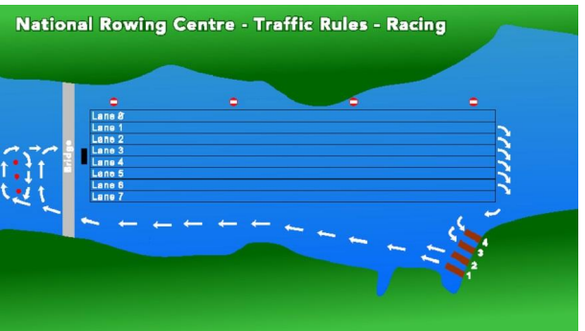

Traffic Issues Near Finish Line
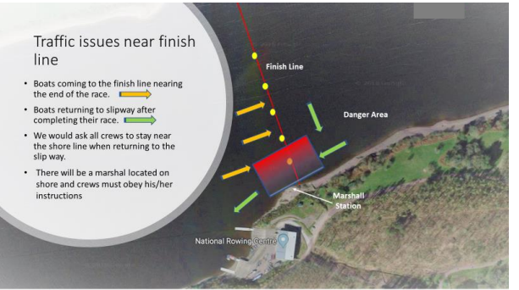

Slipway Traffic Pattern
