Munster Branch
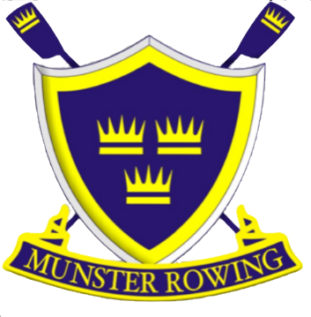
Regatta 2024

National Rowing Centre,
Farran Woods,
Ovens,
Co. Cork P31K704.

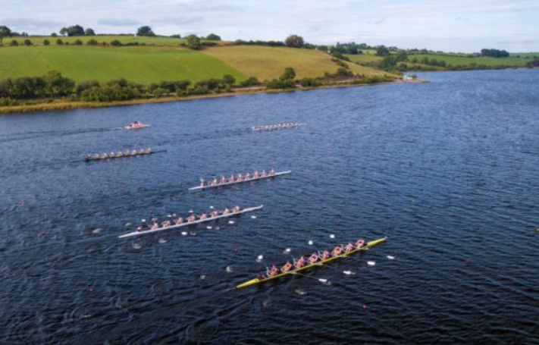

8th June 2024
Following the success of last year’s event The Munster Branch are delighted to announce the second running of a regatta at the National Rowing Centre, the home of Irish Rowing on Saturday 8th June 2024.
The event will take place on the 6 lane 2,000m Albano course at the National Rowing Centre. It is a one- day event and there are changes to the event that we would like you to pay attention to.
This event will be a 2,000m event with all events starting at the stake boats. The sequence is being run the same as the one-day GL schedule. There will be no timing with heats and finals in place. Some categories may be combined to make racing competitive e.g. Senior/Inter/Club together to make heats or finals.
As I am sure you can all appreciate, running events take a great deal of effort from all involved and cooperation and understanding from all clubs is greatly appreciated.

Conditions of Entry:
- This event is being run under Rowing Ireland rules and entries must be made on the Rowing Ireland tracker System before 7pm on the 29th May 2024.
- The event is on a hybrid approach where -by the grand league sequencing of events is being used with only 1 final. Depending on the entries in each group, events in each group may be amalgamated together to facilitate 6 lane racing e.g., Senior / Intermediate and J18 crews amalgamated.
- The sequence of events is below on page 5.
- It is not a Grand League event. It will be run as Heats / Semi Finals (if more than 18 crews entered) / Final.
- The events are in groups, so it may be necessary that more than one grade may be in a race but that will depend on entries. For Example:
  - If there are 3 W J18A 4x- crews entered and 3 W Senior 4x- entered these will be run off as a straight final.
  - The intention is that if there are 6 or less entries in each group then the grades in that group will be run off in one race. At heat time. Reason – we are trying to maximise the lanes used.
- Qualification to finals from events between 7 -18 entries, it will be 2 /3 (depending on number of crews and heats) to qualify from each heat to go straight to the Final. More than 18 crews in any event will result in semi-finals and then a final.
- All masters and junior 14 will start at the stakeboats and finish at the 1,000m mark. J15 events will start at the stakeboats and finish at the 1,500m mark.
- Please note that if you plan on using the same boat twice you will need at least 1 hour between each of the races.
  - The regatta is a full status event.
- Declarations must be made by Wednesday 7th June 2023 by 7pm.
- Entry fees can be paid via Bank Transfer or on the day of the event. If paying on the day of the event please have the correct entry fee. Cheques are to made payable to Munster Branch or alternatively via an electronic bank transfer.
EFT Account: Munster Branch IARU. IBAN; IE08 AIBK 9341 7834 9060 38. BIC. AIBKIE2D
- Races will be provided where there are two or more entries from two different clubs.
- The Munster Branch of Rowing Ireland accepts no responsibility for damaged occasioned to boats, oars or equipment of for any ruling competitors, spectators or any other persons for whatever caused at the regatta.
- Entries will automatically close at 7pm on Wednesday 29th May 2024. A provisional draw will be on the Rowing Ireland website after the entries close. This will be updated following declarations.

- Entry Fees are as follows:
  - J14 & J15 Men & Women Events €8 per seat (exclude cox)
  - Men / Women 4x+ €32
  - Men / Women 2x €16
  - All other categories €12 per seat (exclude cox)
  - Men / Women 8+ €96
  - Men / Women 4+ / 4- / 4x €48
  - Men / Women 2x / 2- €24
  - Men / Women 1x €12
- Presentation of prizes to the winners will take place at designated times on Saturday. Times to be confirmed.
- Please note that all athletes are subject to the possibility of testing by the Anti-Doping Unit of Sport Ireland at this event.
Club Tents:
Club tents will be accommodated. Please try to not block other clubs access.
WC Facilities:
There will be a number of portaloos on site for the event.
Bow Numbers:
Collection of these will be at regatta control. There will be a refundable charge for the bow number of 10 euro.
Trailer Parking:
It is important that we endeavour to provide trailer parking in a safe manner. Clubs are requested to park in a safe place and adhere to any officials. Trailer parking is only permitted on the day of the event and no other time.
The Munster Branch Regatta Committee are looking forward to welcoming you to the event and if you have any queries, please do not hesitate to contact myself at munsterbranch@rowingireland.ie
Further information will be posted closer to the event.
Kind Regards
Nollag Dwyer
Hon Secretary –.
munsterbranch@rowingireland.ie

Saturday 1st Session Heats .
M J14 4x+ ,W J14 2x, MM 4x-, -1,000m Straight Finals.
W Div 1 1x = Snr, Inter, Club 1, J18A
M Div 1 2- = Snr, Inter, Club 1, J18A
M Div 2 8+ = Club 2, J18B, J16, Novice
W Div 2 4x+ = Club 2, J18B, J16, Novice
M Div 1 1x = Snr, Inter, Club 1, J18A
W Div 1 2- = Snr, Inter, Club 1, J18A
M Div 2x = Club 2, J18B, J16
M Div 1 4+ = Snr, Inter, Club 1, J18A
W Div 2 8+ = Club 2, J18B, J16, Novice
W Div 1 4x = Snr, Inter, Club 1, J18A
W Div 2 2x = Club 2, J18B, J16
W Div 1 4+ = Snr, Inter, Club 1,
M Div 1 4x = Snr, Inter, Club 1, J18A.
MM 2X, W J14 4x+, M J14 2x – 1,000m Straight Finals.
Morning Finals

Saturday 2nd Session Heats.
W J 15 2x, M J15 4x+, WM 2x, - 1,500m Straight Finals.
W Div 1 4- = Snr and J18A
M Div 2 1x = Club 2, J18B, J16
W Div 1 2x = Snr, Inter, Club 1, J18A
M Div 2 4+ = Club 2, J18B, J16
M Div 1 2x = Snr, Inter, Club 1, J18A
M Div 1 4- = Snr
W Div 1 8+ = Snr, Inter, Club 1, J18A
W Div 2 1x = Club 2, J18B, J16
W Div 2 4+ = Club 2, J18B, J16
M Div 2 4x+ = Club 2, J18B, J16, Novice
M Div 1 8+ = Snr, Inter, Club 1, J18A
M J15 2x, W J15 4x+, - 1,500m Straight Finals. WM 4x-, 1,000m

2nd Session Finals

