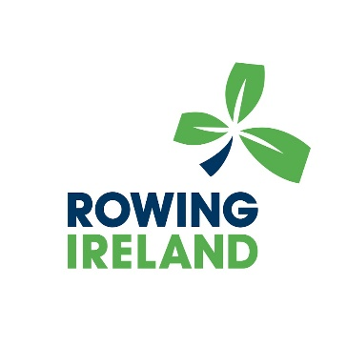

PIRC 2022
Click this link to find out more information about this event and registrations - https://www.iirc.ie/information/

