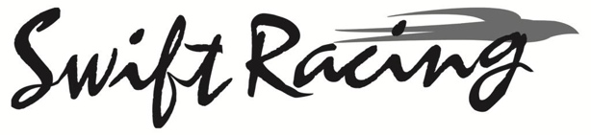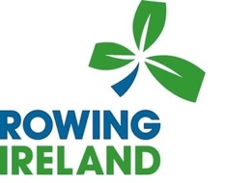
Swift Irish Coastal Championships 2023

Regatta Entry Fees & Details Boat Type

Entry fee
Single - €20.00
Double. - €40.00
Quad. - €80.00
Non Championship Junior Quad races - €50.00

Regatta entry fees are requested to be paid by the close of entry date (19/07/2023) by the club.
Payment is required for ALL crews entered into the competition.
Quote your Club Name as Reference on Payment

Payment Details:
Loughros Point Rowing Club. BK Credit Union, The Diamond Ardara.
BIC – BLDIIE21
IBAN – IE09BLDI99212810433897

