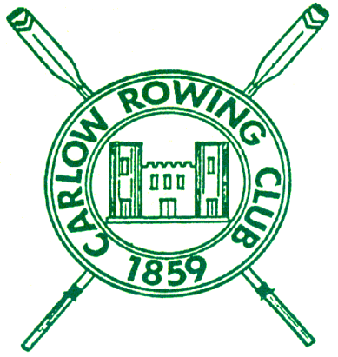
CARLOW ROWING CLUB
Regatta Secretary – Michael Curran
3, The Poplars,
Graiguecullen,
Co. Carlow.
Mob : 087 – 6432830 E –mail: michael58curran@gmail.com

NON-STATUS
CARLOW REGATTA Sunday June 2nd 2024
Under the rules of Rowing Ireland

Dear Captain,
Just a note to thank you for entry to Carlow Regatta which is much appreciated. Timetable of events will follow over the weekend. If I can be of any further assistance, please feel free to contact me and I will be available at the club both days.
Yours sincerely,

_________________________________
Michael Curran
Regatta Secretary
PTO

CARLOW REGATTA

Sunday June 2nd

Overnight Trailer Parking

Overnight Parking will be available at the Carlow Town Hall Car Park which is 100 Metres form the Club on Saturday night for all clubs who require it.

Overnight security will be provided

Please note that all Junior 14 and under sculling events will be from the shorter start
PTO

Additional Safety Message

While we do encourage coaches to cycle up to the start and follow races. It is important that all coaches or anyone else who is cycling the course that they obey instructions from stewards. Failure to obey stewards may result in a false start been awarded to that crew.

Please make sure you have enough equipment for your crews as we may not be able facilitate race changes.

