NEW ROSS HEAD OF THE RIVER 2022
Updated Itinerary
Traffic System in St Mullin’s
- Only boat trailers will be allowed access to the launch area at St Mullins.
- Car park available in St Mullin’s village.
- Please pay attention to Marshalls and follow their instructions.
- Parking for trailers is tight on space so we request that once your trailer is unloaded your trailer should return to New Ross boat Club where you will be met with marshals to show you where to park. Trailers will park in field beside New Ross Boat Club.
- Trailers should arrive no later than 8am. Allow for a small delay when arriving to get all trailers in for parking.
- Rowers must arrange their own transport back to St Mullins to collect any cars.
Registration/Bow numbers
- Bow numbers available from Race Control at the registration tent and will only be given once entry fees paid. Please pay in advance where possible.
- Course maps and instructions will be handed out with all bow numbers.

Itinerary
08:00 Registration/Bow numbers – St mullins
08:30 Cox’s Meeting - St. Mullin’s
08:50 Launch of boats – lowest numbers first
09:30 Race start –with 30 seconds between boats

Race Start Old Stone Bridge, St. Mullin’s
Race Finish 50metres past New Ross Boat Club at Apartment block (before bridge) Hooter will sound as you finish.

Additional information:
- Boat launching in St Mullins will require wellies as there is no dedicated pontoon
- St Mullichains café will be open in St Mullins from 8am for tea/coffee/breakfast rolls
- Hot food will be available to purchase at New Ross Boat Club at the finish
- Prizes will be awarded to crews where 2 or more entries in the event. Also prizes will be awarded to the fastest adult male and female crew and Junior male and female crew.
- A call will be made on Thursday by 5pm if the event needs to be cancelled due to weather

Finish Pattern:
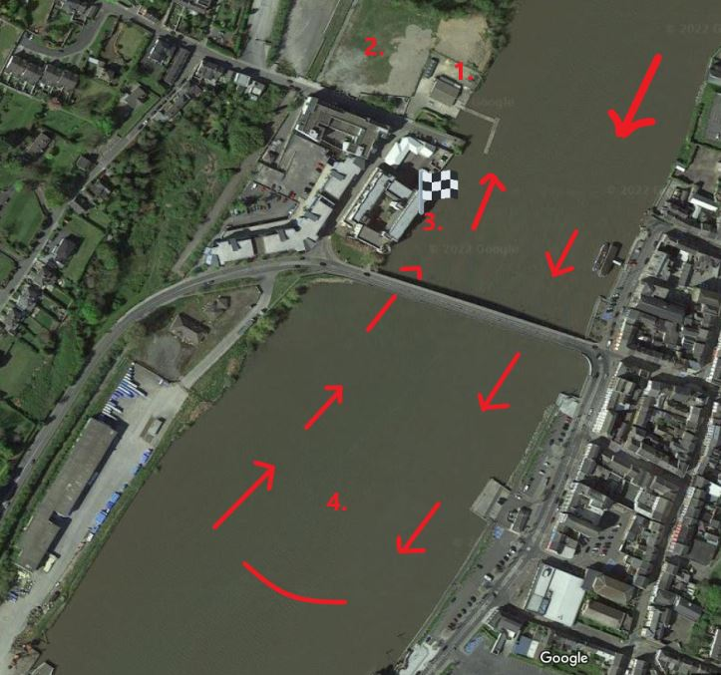
Key positions:

1: New Ross Boat Club
2: Trailer and car park
3: Finish
4. Warm down area – row through the bridge down past Dunbrody ship and safety boat
All crews turn in a clockwise direction and return to the boat club

